System Administration & Maintenance

Game Credit Service

Member:
BARRETE, ALLIANA N.
JORDAN, JOSEPH G.
BELARMINO, JOHN LEI
Course & Section: BSIT - 3206
Professor: Patrick David B. Lim, LPT Submitted: May 22, 2025

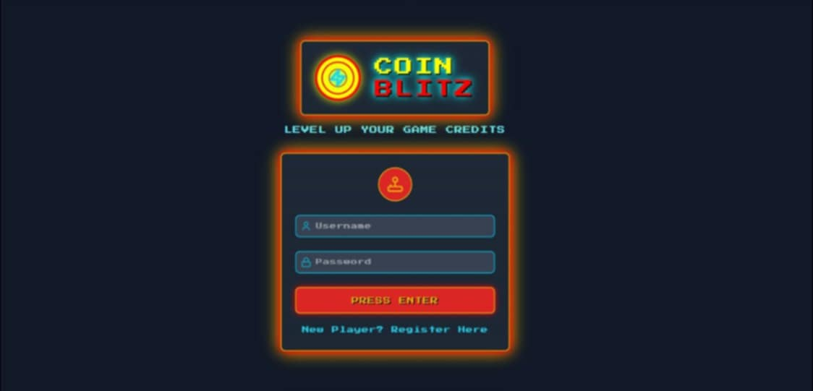

Login UI

Purpose: Authenticates users to access the COIN BLITS platform
Components:
- Username field
- Password field
- “PRESS ENTER” (Login) button
- “New Player? Register here” link

Functionality:
-Validates credentials against stored user data
- Redirects to the dashboard upon login.
-Displays error massages for invalid inputs.

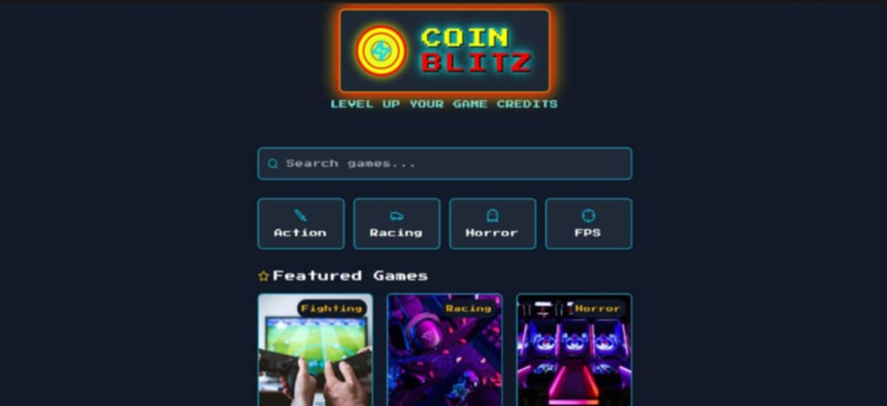


Dashboard

Purpose: Enables users to buy in-game credits.
Components:
-Credit package options (e.g., 100 credits for 5, 500 credits for P20).
- “SELECT” buttons for each package.
- Navigation to payment gateway.

Functionality:
- Displays available credit packages.
- Redirects to payment confirmation upon selection.

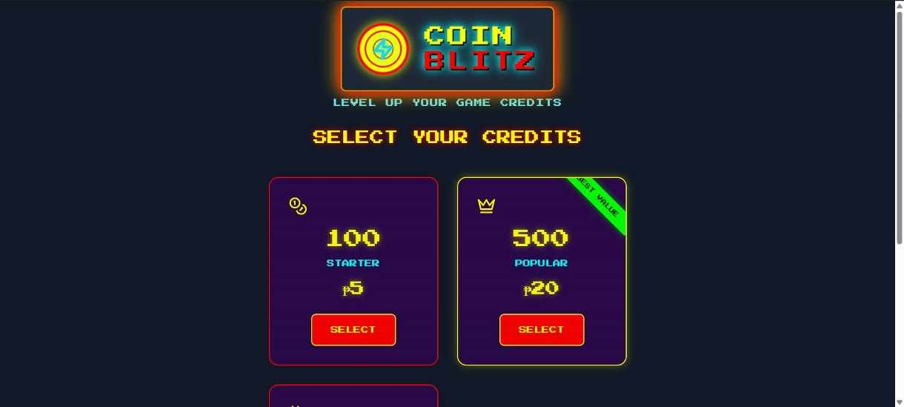

Purchase Credits Interface

Purpose: Enables users to buy in-game credits.
Components:
-Credit package options (e.g., 100 credits for 5, 500 credits for P20).
- “SELECT” buttons for each package.
- Navigation to payment gateway.

Functionality:
- Displays available credit packages.
- Redirects to payment confirmation upon selection.

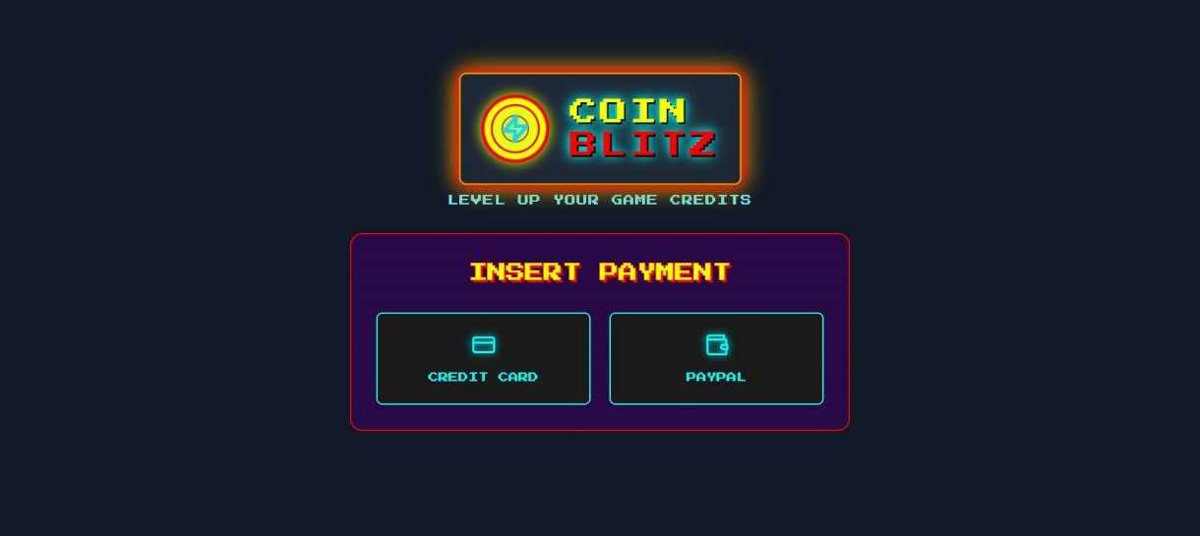

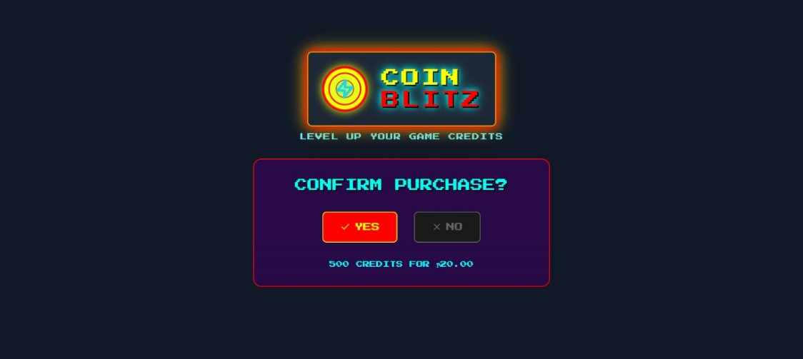

Payment Method

Purpose: Facilitates secure payment processing.
Components:
-Payment options (Credit Card, PayPal).
- Input fields for card details or PayPal login.
– PROCESSING... status indicator.

Functionality:
- Encrypts sensitive payment data.
- Integrates with third-party payment gateways.
- Disables navigation during processing.

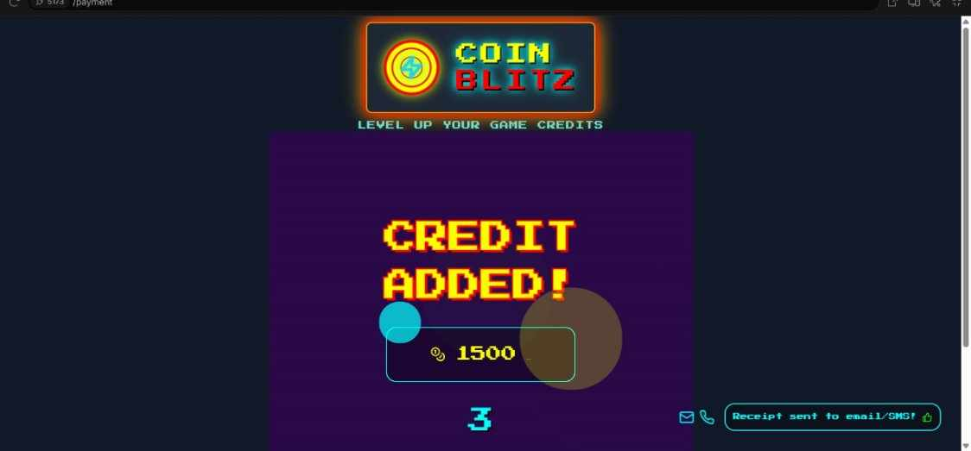

Successful Purchase

Purpose: Display the credit added if the purchase is successful.
Components:

Functionality:

Maintenance

Preventive Maintenance:

Corrective Maintenance:

Checked by:

Score:

Score:

Score:

